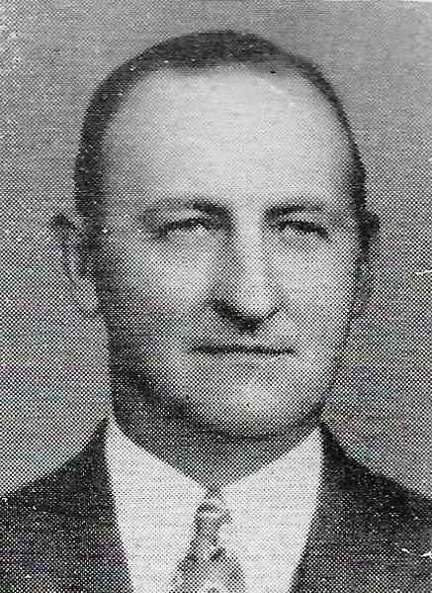
Taylor Boyd

Taylor was an Indiana native who, at the age of 30, relocated to Cincinnati to oversee the construction of Kenwood Country Club. The year was 1929. Taylor recalled that there were as many as 800 men on the work site at one time. The men were paid $1.00 per day or, if they had a work horse, $2.00 per day as long as they could show proof of horse feed purchases.

Once construction was complete, Taylor remained as Kenwood’s Golf Course Superintendent until 1949. He then moved to Camargo Country Club where he was Superintendent until 1961. Taylor finished his career at Losantiville Country Club retiring in 1968.

Taylor was one of the founders of the Greater Cincinnati Golf Course Superintendent Association. He served as the very first President in 1931 and then again in 1957. Taylor was also the President of the Mid-West Turf Foundation in 1953 and 1954.

Taylor dabbled in Gold Course Architecture building the Frontier Golf Course for Kenton County. In1960 he built Eagles Nest Golf Course.

