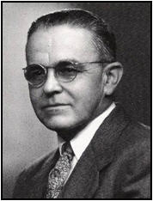
Clifford R. Runyan
(1892-1955)

Clifford attended the Ohio State University Agricultural College. In 1915, he received the first degree in Landscape Architecture ever awarded by OSU.

He was a commissioned Air Corps officer in World War I, and he became the Assistant Superintendent at Spring Grove Cemetery in 1920. He took over the head position at Spring Grove in 1926 and held the position for almost 30 years, until his death in 1955.

Clifford was very active in the Horticultural Society of America and was instrumental in helping form the GCGCSA. Although he was an expert in ornamentals, he had a very keen and special interest in turfgrasses. In fact, he was the first person in Ohio to cultivate Meyer Zoysia, promoting it not only on the cemetery grounds, but also in the suburbs for home lawns.

Besides a great interest and dedication to our organization, Clifford was a member of the Grass Research Committee of the American Cemetery Association and a director of the Board of the Midwest Turf Research Foundation at Purdue University.

Clifford was a man of many talents and a great example of how our organization reached out to all those in turf-related fields right from the start.

